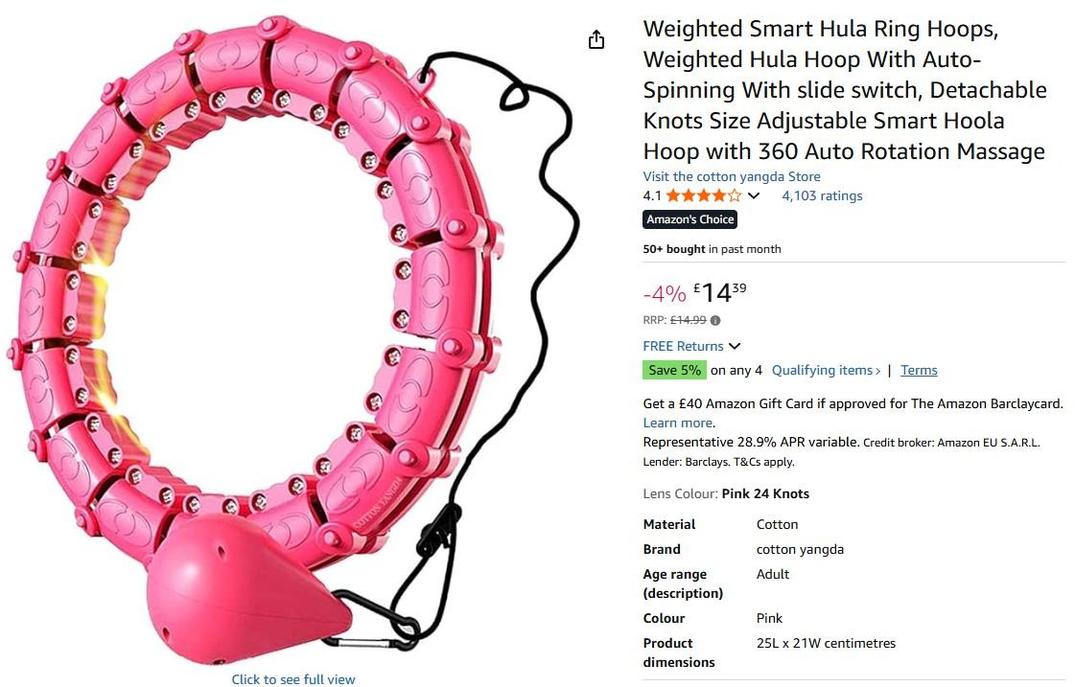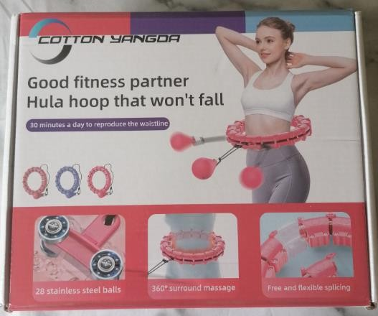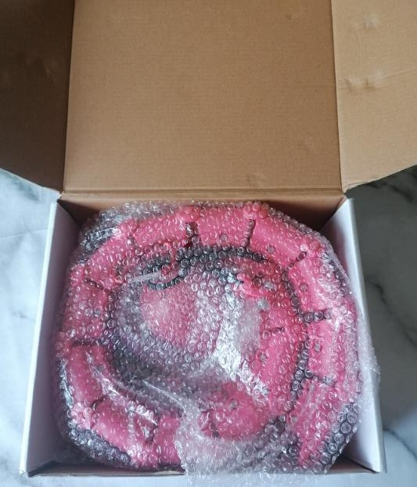

2,500pcs x Weighted Smart Hula Hoop with Auto-Spinning, Detachable Knots 360 Rotation Originally selling on amazon for

£14.99

Red – 500pcs Black – 500pcs White – 500pcs Red – 500pcs Blue – 500pcs